13

**Math Games: Practicing the Basics Is Fun!**

**Bonnie Goonen – bv73008@aol.com**

**Susan Pittman-Shetler – skptvs@aol.com**

Table of Contents

Ten of the Very Best Reasons for Using Classroom Games and Activities 2

Fact Drills 4

Math Test Instructions 6

Card Games 8

Whole Numbers 8

Fractions 9

Integers 11

Number Cubes/Dice Games 12

Whole Numbers 12

Calculator Activities 15

Beat the Calculator 15

Place Your Order! 16

Calculator Tic – Tac – Toe 17

Toothpick Puzzles 18

Toothpick Teasers 23

Additional Games/Activities 26

Mars Fraction Hunt 26

A Few Patterns 32

Starting with Number Lines for Positive and Negative Integers 35

# Ten of the Very Best Reasons for Using Classroom Games and Activities

Classroom games and activities are an excellent way to develop mathematical skills through practice, as well as to develop problem solving, critical thinking, and teamwork. Games can be used in the adult education classroom to engage students in the learning process while having fun. The primary goal of games should be to build teamwork while developing new skills and knowledge. From games, students can learn not only the “what,” but also the “why” and “how” of the topic. The real benefit of creating games for the adult education classroom is that the activities can meet the individual needs of the student and the subject matter being taught.

The potential list of games is endless. This section includes an article from Steve Sugar on “Ten of the Very Best Reasons for Using Classroom Games,” as well as a few ideas to get teachers started in creating games and activities for the classroom.

Ten of the very best reasons for using classroom games as part of the curriculum are:

**Reason #1: Games are Fun with a Purpose**Games create a cognitive engagement between the learner and the topic in a flowing, smiling environment. Games celebrate your topic and reward individual and group achievement. Games bring fun and energy into a buoyant learning zone, but with the focus on learning.

**Reason #2: Games Provide Feedback to the Learner**Learners want and need feedback on their performance. Games give them immediate feedback on the quality of their input — their successes and their errors. With the appropriate corrective feedback, this can become an invaluable learning opportunity.

**Reason #3: Games Provide Feedback to the Teacher**Games provide a practice field where learners interact with the topic, demonstrating their knowledge and ability to apply the information. By observing this real-time demonstration, the teacher can adjust the subsequent level of lecture, readings, and interventions accordingly.

**Reason #4: Games are Experiential**Today’s learner needs to do and to try things on his/her own. Games provide an environment that transforms the passive student into an active part of the learning process where he/she can connect his/her own dots and experience his/her own ideas. Games also remind both player and teacher that energy in the classroom is a good thing.

**Reason #5: Games Motivate Learners**Games engage players and then motivate them to interact with the topic. This interaction drives players to demonstrate their understanding of the topic in a friendly contest where successes are memorable moments of shared triumph and celebration and where mistakes mean only that the learner is being stretched to his or her own limits.

**Reason #6: Games Improve Team Work**Games are real-time activities that bring players into teams, demonstrate the rules and roles of working together as a team, and underscore the value of team collaboration. Games give your learners a chance to know their peers as they share the same real-time experiences, allowing for strong networking and bonding.

**Reason #7: Games Provide a Less Threatening Learning Environment**Because the game format is playful, the inherent challenge of the material, even new or difficult material, is less threatening. During game play, seemingly difficult questions and scenarios are “just part of the game.” And, teachers can use the window following responses to build a bridge between the topic and the learner.

**Reason #8: Games Bring Real-World Relevance**Games allow you to present real-world information in the form of questions, scenarios, role-plays, and so forth. In this way, players learn not only the “what,” but the “why,” of the topic from a real-world perspective. Players also observe their own behavior and that of others during game play. Post-game debriefings give insights into those behaviors in thoughtful examples observed during game play.

**Reason #9: Games Accelerate Learning**Games allow you to compress your topic and demonstrated learning into shorter periods of time, accelerating the speed of learning. The visual presentation, oral interactions, and active participation of game play appeal to all of the learning styles (visual, auditory, and kinesthetic), involve both the rational and experiential mind, and help players remember what they have learned.

**Reason #10: Games Give You Choices for Your Classroom**Games allow you to add variety and flexibility to your teaching menus. Games can allow you to do any or all of the following:

* Increase the level of learner involvement
* Vary the level of skill and knowledge
* Customize to any size of audience, even one-on-one
* Vary the type and level of activity
* Vary the level of classroom control
* Introduce or review topics, or both
* Vary the mix of theoretical and practical information

Sugar, S. The Game Group. Retrieved from the World Wide Web at: http://www.thegamegroup.com/article1.htm.

## Fact Drills

Fact drills are the best way to help students learn the basics. There are pre-made flash cards for almost any type of fact, but having students make their own cards is a great way to reinforce the facts that they will be learning.

### Bingo

Everyone knows the game. It is for exactly that reason that bingo is such a useful game to play in the classroom. The thrill of shouting out "BINGO!" lasts a long time. Of all the [games](http://curriculalessons.suite101.com/article.cfm/why_play_math_games) that can be used in the classroom setting, the game of bingo is among the most useful and effective. Below is a list of suggestions for some ways to use bingo in your math class.

**Addition Bingo**

This version of bingo is a good tool for helping students learn basic addition and subtraction fact. The teacher calls out "seven plus two" and the students look for a nine to cover up, or the teacher calls out "14 minus seven" and the students look for a seven to cover up on their bingo cards. This game can also be played in reverse, with problems like 11-4 or 5+7 on the cards and the teacher calling out possible answers for the students to match with problems.

**Multiplication Bingo**

This game is almost exactly like addition bingo except that multiplication (or division) problems are used. If you're making cards that have answers and you're calling out problems, be sure **not** to put [prime numbers](http://primes.utm.edu/lists/small/1000.txt) on the cards; the student will never cover 23, 57, or 59, for example, because there are no multiplication problems that have those numbers as answers (except one times that prime number). It's an easy mistake to make.

**Rounding Bingo**

Using a normal bingo card, call out multiples of 10 and tell students that they can only cover up one number that can be rounded to that particular multiple of ten. You call out 20 and the student can cover, for example, 17 or 22. Of course, this is another game that can be reversed. The card can contain only multiples of 10 (or one hundred, or one thousand...) and when the teacher calls out 39 or 43, the students have to cover 40.

**Factor Bingo**

Fill up a small bingo card with numbers under 20 or 30 and call out larger numbers. The students can cover up a number if it is a factor of the number you called out. So, if you called out 60, a student could cover one, two, three, four, five, six, 10, 15, 20, 30, or 60, since all of those number are factors of 60. Of course, the student can only cover one number.

**Fraction and Decimal Bingo**

This version of bingo is used to practice converting fractions to decimals and vice versa. The teacher calls out "zero point two five" and the students cover up 1/4 on their cards. In the reverse version the teacher calls out fractions like 11/20 and the student has to cover up 0.55 on the card.

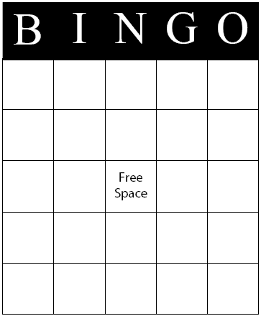

## Math Test Instructions

Tell participants that the following test is a simple one involving easy addition, subtraction, multiplication, and division problems. Often our students need basic review in number operations before they can go on to higher order math skills so this is a good quick review system.

Pass the papers out face down. Then tell them that as soon as you say “Go,” turn the papers over and work as fast as they possibly can so that they are the first ones done. As soon as someone is finished, he/she should shout, “Done.”

Provide instructions hurriedly and allow no time for questions. Allow them about 30 seconds and say: I see that most of you are done so let’s begin.

Have the participants share their answer for the first few questions. When there is a discrepancy, ask: Did you all get the same sheet?

Have the group discover the problem by reading the directions to themselves.

Discussion Questions

1. Remember the saying, “If all else fails, read the directions?” Why didn’t we all read the directions? (pressed for time, saw familiar problems)
2. Have you ever seen incidents where poorly given or rushed instructions may be worse than none at all?
3. Did anyone experience group pressure when you began to start this exercise? What effects did this have on your performance?
4. Are there any similarities to how the group responds to math problems?

### Mathematics Test

In the following simple math problems, a plus (+) sign means to multiply, a divide (÷) sign means to add, a minus (−) sign means to divide, and a times (×) sign means to subtract. Complete the problems.

|  |  |
| --- | --- |
| 17 x 2 = | 8 + 2 = |
| 14 **÷** 7**=** | 15 x 3 |
| 8 + 2 = | 14 – 7 = |
| 9 + 11 = | 6 x 5 = |
| 4 x 3 = | 8 + 3 = |
| 6 **÷** 2 = | 7 x 2 = |
| 9 – 3 = | 9 + 2 = |
| 7 x 4 = | 8 – 4 = |
| 4 + 4 = | 9 + 6 = |
| 8 – 4 = | 1 **÷** 1 = |
| 12 x 2 = | 8 x 7 = |
| 20 – 1 = | 13 – 1 = |
| 9 – 1 = | 16 – 4 = |
| 5 + 6 = | 9 x 2 = |
| 2 x 1 = | 9 **÷** 9 = |
| 10 – 5 = | 6 x 2 = |
| 12 + 2 = | 8 + 4 = |
| 6 **÷** 6 = | 10 – 2 = |
| 8 + 5 = | 4 – 1 = |
| 6 + 6 = | 18 – 3 = |
| 17 x 2 = | 8 + 2 = |
| 14 **÷** 7 = | 15 x 3 = |

# Card Games

## Whole Numbers

### Multiplication War (Multiplication Fact Practice)

Objective: To provide practice in basic multiplication facts.

Materials:

Deck of playing cards

How to Play:

1. Divide students into pairs. Remove the Kings, Queens, Jacks, and tens from the deck of cards. Use the Ace as a one. Cards rank from high to low: 9, 8, 7, 6, 5, 4, 3, 2, 1 (Ace). Suits are ignored in the game.
2. Deal out all of the playing cards between the players. Players do not look at their cards, but keep them in a pile face down. The object of the game is to win all of the cards.
3. Both players turn their top card face up and put them on the table. The player who says the product correctly first, gets to keep both cards.
4. If the turned up cards are equal, there is a war. The matching cards stay on the table and both players play the next card of their pile face down and then another card face up. The player who says the product of the new face up cards quickest wins the war and adds all six cards face down to the bottom of their pile. If the new face up cards are equal as well, the “war” continues until the cards are different.
5. The game continues until one player has all of the cards. This can take time, so the teacher may wish to give a time limit.

### Bull’s Eye (Order of Operations Practice)

Objective: To hit the target number first by arranging cards to create an equation.

Materials:

A deck of playing cards

How to Play:

1. Remove the 12 face cards from the deck and set them aside.
2. Shuffle the rest of the deck and deal four cards face down to each player. Turn the next card face up in the center of the table. This is the target number.
3. At the count of three, all players turn their cards over at the same time. Then they +, −, ×, or ÷ the numbers on their cards (Aces = 1) and try to equal the target number. All four cards must be used.
4. Examples: If the target number is 5 and one draws a 2, 9, A (1), and 7, an equation to equal the target number could be: (9 −7) x 2 + 1 = 5.
5. The first player to equal the target number gets 1 point., with 3 points winning the game.
6. If no one can equal the target number, turn over another card for a new target number or redeal.

Winning Strategy: Keep rearranging your cards until you see the right combination. Also, try to group a pair of cards together.

## Fractions

### Fraction Cards

Develop a set of fraction cards. You will need two of each fraction card. Index cards are the best with which to work because they are similar to regular playing cards.

* 1/2, 2/2
* 1/3, 2/3, 3/3
* 1/4, 2/4, 3/4, 4/4
* 1/6, 2/6, 3/6, 4/6, 5/6, 6/6
* 1/12, 2/12, 3/12, 4/12, 5/12, 6/12, 7/12, 8/12, 9/12, 10/12, 11/12, 12/12

Divide students into teams of 2, 3, or 4. Each person is dealt one fraction card up and one fraction card down. Players can look at the card turned down and decide whether they want another card or whether they want to pass. The goal is to be closest (without going over) to the whole number 2.

This activity requires that students be able to add unlike fractions and be able to change improper fractions to a mixed number.

### Fractional Go Fish! (Equivalent Fraction/Decimal Practice)

Objective: To create pairs of equivalent fractions/decimals.

Materials:

* Deck of 40 cards with at least one equivalent for each card (e.g. ½ and .5)

How to Play:

1. In small groups of 3-4, students play with a deck of 40 cards (larger if desired). Within each deck there needs to be at least one equivalent for each card. (May be more for faster games.) Fractions pair with equivalent decimals.
2. Cards are dealt out 5 cards per player and the rest are spread out in the centre. Players must make pairs, which they set down on the table.
3. After the deal, the first player in turn asks another player “Do you have _______?” The card the student asks for must be stated in the equivalent form to the card for which the student is seeking a match. (e.g., If the player is holding decimal five, the player would ask for one half. If the player is looking for the match of two thirds, the player would ask for decimal six repeating.)
4. A player lays down matching pairs during his’/her turn and the turn passes. If the player does not get what the player needs, the player is told to “Go Fish” and draws one from the center and the turn moves on.
5. The game ends when either one player is out of cards or center cards are gone. The winner is the person with the most pairs.
6. Determining the player with either the greatest or least cumulative value in the pairs could break ties.

### A Variation on “Old Maid”

Objective: To match fractions and decimals or percents dependent on what type of practice is needed by students.

Materials:

* A created deck of 40-50 matching cards (larger if desired) and one non-matching card. The non-matching card can be an irrational value, such as pi or it may be a numerator divided by zero. The students should know why this value cannot be matched.

How to Play

1. Deal out all of the cards to the players. Deal and play are clockwise.
2. Players should make as many pairs from their cards as possible and set them down on the table.
3. Next, the dealer begins. At each turn, the player offers his/her cards spread down to the player to his/her left. That player selects a card from the other’s hand without seeing it and adds it to his/her hand. If it makes a pair, he/she discards the pair. The player who just took a card then offers his/her hand to the next player to his/her left, and so on.
4. Players who make pairs and lay down all their cards are safe - the turn passes to the next player. Eventually all the cards will have been matched except for the odd card (the old maid) and the final holder of this non-matching card loses.

### A Variation on Rummy (Equivalent Fraction and Decimal Practice)

Objective: To match three fractional equivalencies and the equivalent decimal value.

Materials:

* Deck of 52 matching cards. There should be three equivalent fractions and the equivalent decimal for each value. Example: ½, 2/4, 3/6, and .5.

How to Play:

1. Deal out seven cards to each play. Deal and play are counter clockwise. Place the remaining cards face down in the center of the table with the top card turned up.
2. Players make matches of three fractional equivalency cards, which they set down on the table.
3. The player left of the dealer begins. At each turn, the player either picks up a card from the face down pile or takes the top card of the discard deck. If more than one card is in the discard pile, a player has the option of picking up one card or the entire discard pile. If the player has three values that are equivalent, the player lays down his/her “three of a kind.” The player then ends his/her turn by discarding a card.
4. If someone has played one half, two fourths and three sixths, another player can play his/her matching decimal five during his/her turn.
5. Play continues until one player lays down his/her final card. The winner is the player with the greatest number of matching cards laid down.

## Integers

### Positive and Negative Integers: A Card Game

**Objective:** Students will practice addition and subtraction of positive and negative integers using an adaptation of the card game Twenty-Five.

**Materials:** Standard deck(s) of playing cards

**Procedure:**

Arrange students into groups of two or more. Have students deal out as many cards as possible from a deck of cards, so that each student has an equal number of cards. Put aside any extra cards.

Explain to students that every black card in their pile represents a positive number. Every red card represents a negative number. For example, a black seven is worth +7 (seven), and a red three is worth -3 (three). Face cards have the following values: aces have a value of 1, jacks have a value of 11, queens have a value of 12, and kings have a value of 13.

At the start of the game, have each player place his/her cards in a stack, face down. Then ask the player to the right of the dealer to turn up one card and say the number on the card. For example, if the player turns up a black eight, he or she says “8.”

Continue from one player to the next in a clockwise direction. The second player turns up a card, adds it to the first card, and says the sum of the two cards aloud. For example, if the card is a red 9, the player says: “8” + (-9) = (-1).”

The next player takes the top card from his/her pile, adds it to the first two cards, and says the sum. For example, if the card is a black 2, the player says: “(-1) + 2 = 1.”

The game continues until someone shows a card that, when added to the stack, results in a sum of exactly 25.

**Extra Challenging Version**

To add another dimension to the game, you might have students always use subtraction. Playing the game this way will reinforce the skill of subtracting negative integers.

For example, if player #1 plays a red 5 (-5) and player #2 plays a black 8 (+8), the sum is -13: (-5) – (+8) = -13.

If the next player plays a red 4, the sum is -9: (-13) – (-4) = -9. (Remember, subtracting a negative number from a negative number is equivalent to adding that number.)

# Number Cubes/Dice Games

## Whole Numbers

### Snake Eyes (Addition Practice)

Objective: The winner is the first person to score 100 points by rolling the dice. It’s not as easy as it sounds, because there is a dangerous “snake” waiting to steal all of your points every time you roll the dice!

Materials:

* A pair of dice/number cubes
* Paper and pencil
* Calculator

How to Play:

1. Make a score card with each player’s name on a piece of paper.
2. Roll the dice to see who goes first, then each player takes turns rolling the dice.
3. On your turn, roll the dice and find the sum of the numbers rolled. You can quit and write down that total or you can roll again. As you continue rolling the dice, keep a running total in your head. When you decide to quit, add that total to your score on the score card.
4. You can keep rolling as long as you want, but if a 1 comes up on one of the dice, you lose all of your points for that turn. If two 1s come up (snake eyes), you lose all of your points for the whole game and must start over again at 0.
5. The first person to score 100 or more points is the winner.

Winning Strategy: The probability of getting a 1 on one of the dice is 10 out of 36. This is about one-third. The probability of getting snake eyes is 1 out of 36. Keep this in mind as you decide how many times to roll the dice on each turn.

Variation: Change the winning total to 250 points and count doubles as double their sum. For example, two 6x equals 12 and double that would add 24 to your total. If a 1 comes up, you still lose your points for that turn. However, in this game, snake eyes (two 1s) is worth 25 points.

### Race to Zero (Subtraction Practice)

Objective: Use problem solving and subtraction skills to try and race each other to the number zero, without going below zero. Students must find the difference of two numbers by solving self-generated subtraction problems.

Materials:

* A pair of dice/number cubes
* Paper and pencil
* Calculator

How to Play:

* 1. Divide students into pairs. Give each pair a set of dice/number cubes, pencil, two pieces of paper, and a calculator.
  2. Tell the students to write the number 100 at the top of their sheet of paper and 0 at the bottom.
  3. Students should decide who will be Player A and who will be Player B. Player A tosses the dice and creates a two-digit number (e.g., 4 and 5 could be 45 or 54). The player then subtracts that number from 100 and checks his/her answer on a calculator. Play B then takes a turn. Play continues alternating between Players A and B. The winner is the player who comes closest to zero without going below zero.

Winning Strategies: Have students share what strategies they used to try and win the Race to Zero. Have students share their responses and play the game with a new partner. Discuss new strategies that they tried.

### 0 – 99+ (Addition and Subtraction)

This is a mental arithmetic game involving addition and subtraction of whole numbers game for 2-6 players or teams. The object of the game is to be the last player in the game by forcing opponents to roll a value which makes the running total larger than 99.

Each game starts with a running total of zero.

Play proceeds clockwise around the table or playing area. In turn, each player tosses the dice and adds or subtracts the sum to the running total. If a die total is not 9 or 10, players must add the sum to the running score. If a die total of 10 is rolled, a player may + or – 10 to or from the rolling total. If a die total of 9 is rolled, a player may + or – 9 to or from the running total. Each player must roll on each turn and finish his/her play by giving the new correct running total. If a player’s answer is incorrect, that player is out of the game.

Example: The previous running total is 80. Player 1 rolls 3, 4 and announces that the new running total is 87. Player 2 rolls 6, 6 and announces that the new running total is 99. Player 3 rolls 5, 4 and announces that new running total is 90.

### Fraction Activities

**Activity I**

List some measurements in everyday life that require the use of fractions.

**Activity 2**

Have students work in teams of two. Give each team one pair of dice. The object of the game is to see which member of the team is the first to score 20.

Each team member rolls the dice in order to get a fraction.

Example: 4 and 5 gives 4/5

Player A gets a point if the fraction is in lowest terms (like 4/5)

Player B gets a point if it is not in lowest terms (like 4/6)

The first player to reach 20 points wins.

**Activity 3**

Have students work in teams of two. Give each team one pair of dice. The object of the game is to see which member of the team is the first to reach a total of 10.

Each team member rolls the dice in order to get a fraction.

Example: 4 and 5 gives 4/5

Each player must add his/her fractions each time the dice is rolled. For example on the first roll Player A get 2 and 3 (2/3). On his/her second roll he/she gets 3 and 4 (3/4). The player must then add 2/3 and 3/4 to get a total of 1 5/12 on his/her next roll, the player must add the new fraction to the last total and so on.

The players alternate rolls until one of the players has reached at least 10.

# Calculator Activities

## Beat the Calculator

Materials:

* A calculator
* Number cards 0-9 (4 of each)

How to Play:

1. Each group has three players. One player is the "Caller." A second player is the "Calculator." The third player is the "Brain."
2. Shuffle the cards and place them face down on the table.
3. The Caller draws two cards from the number deck and asks for the sum of the numbers.
4. The Calculator solves the problem with a calculator  
   The Brain solves it without a calculator. The Caller decides who got the answer first.
5. Players trade roles every 10 turns or so.

Variations:

* Play the game with multiplication facts instead of addition facts.
* Play the game with the entire class. Students on one side of the room are Brains and the other students are Calculators.

## Place Your Order!

Use your calculator and insert the addition, subtraction, multiplication, or division signs into the blanks. You may also use any other mathematical symbol that might help (such as parentheses or a square root). You may use any operation or symbol more than once.

1 ____ 1 ____ 1 ____ 1 = 1

2 ____ 2 ____ 2 ____ 2 = 2

3 ____ 3 ____ 3 ____ 3 = 3

4 ____ 4 ____ 4 ____ 4 = 4

5 ____ 5 ____ 5 ____ 5 = 4

6 ____ 6 ____ 6 ____ 6 = 4

7 ____ 7 ____ 7 ____ 7 = 3

8 ____ 8 ____ 8 ____ 8 = 2

9 ____ 9 ____ 9 ____ 9 = 1

**Place Your Order Answer Key**

(1 + 1) / (1 + 1) = 1

2 / 2 + 2 / 2 = 2

3 x 3 – (3 + 3) = 3

(4 - 4) / 4 + 4 = 4

(5 x 5 – 5) / 5 = 4

6 – (6 + 6) / 6 = 4

(7 + 7 + 7) / 7 = 3

8 / 8 + 8 / 8 = 2

9 – 9 + 9 / 9 = 1

## Calculator Tic – Tac – Toe

Play calculator tic – tac – toe! Choose a partner to play against. The first player chooses a number from 1 to 25. The player completes the calculation. If the answer is one of the numbers in the square, the player marks that square with either an X or O. It then is the next player’s turn. If the answer is not in a square, the player loses that turn and it becomes the next player’s turn. Alternate until someone has tic – tac – toe! The game can be played repeatedly.

87.5

-3

189

10

12.5

25

10

7/16

4 5/6

-66

1. 10 (3 + 12) + 39=
2. 100 ÷ (12 – 8) + 62.5 =
3. 3 ½ + 4 2/3 – 3 1/3 =
4. (3.59 + 4.2 + 7.9) ÷ 3 =
5. (2 5/8 – 1 3/8) x 4 + 20 =
6. (3/4 + 1/8) ÷ 2 =
7. 1/2 x 7/8 =
8. 4 is 16% of what number?
9. What is 125% of 70?
10. 10 is what percent of 80?
11. Subtract a 15% discount from $180
12. What is the increase from $147.50 to $162.25?
13. What is the decrease from 32 to 24?
14. 15 – (-35) =
15. (7)(3) + (-7) (-7) – 3 =
16. (-12) + (-31) + (-23) =
17. (-2) (6¼) (-7) =
18. 5x + 2 = -13, x = ?
19. 52 x 32 – (-62) =
20. √9 =
21. 4 5/6 + (4 5/6 x 2) – (9 2/3) =
22. 7.52 + √100 – (-21.25) =
23. 33 + (-99) =
24. (–35 x 7) + 179 =
25. 2 x 1 1/5 + 4 x 2.5 – 2 2/5 =

# Toothpick Puzzles

The following are some puzzles using toothpicks that you may want to use to improve problem solving skills in a fun way.

Puzzle #1

Use 17 toothpicks to construct this figure.

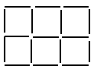

Remove 5 toothpicks and leave 3 squares.

b. Remove 6 toothpicks and leave 2 squares.

Answers for Puzzle #1

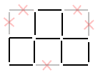 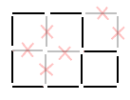

Puzzle #2

Make this figure with 12 toothpicks.

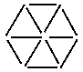

a. Remove 4 toothpicks and leave 3 triangles.

b. Move 4 toothpicks and form 3 triangles.

Answers Puzzle #2

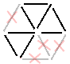



Puzzle #3

With 9 toothpicks, make this figure.  
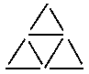

Remove 2 toothpicks and leave 3 triangles.

Remove 3 toothpicks and leave 1 triangle.

Remove 6 toothpicks and get 1 triangle.

Remove 4 toothpicks and get 2 triangles.

Remove 2 toothpicks and get 2 triangles.

Answers Puzzle #3

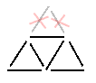 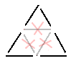 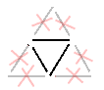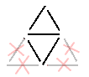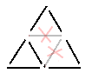

Puzzle #4

Use 8 toothpicks and 1 button to form a fish.



Move 3 toothpicks and the button to make this fish swim in the opposite direction.

Answer Puzzle #4

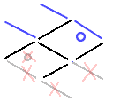

Puzzle #5

Two farmers have land this shape.



The first farmer wants to divide her land evenly between her 3

daughters. Add 4 toothpicks to form three parcels of equal size and identical shape.

The second farmer wants to divide her land evenly among her 4 daughters. Use 8 toothpicks to form four parcels of equal size and identical shape.

Answers Puzzle #5

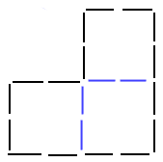 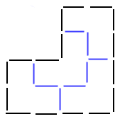

## Toothpick Teasers

**Problem 1:** Build a house using 11 toothpicks as shown in the diagram. See if you can make the house face the opposite direction by moving only one toothpick.

Answer: Move the center diagonal toothpick in the roof and slant it to the right corner.

**Problem 2:** Arrange 12 toothpicks as shown in the diagram. Can you move only three toothpicks and end up with exactly three congruent squares?

Answer:

**Problem 3:** Arrange 16 toothpicks as shown in the diagram. Remove four toothpicks so that only four triangles remain.

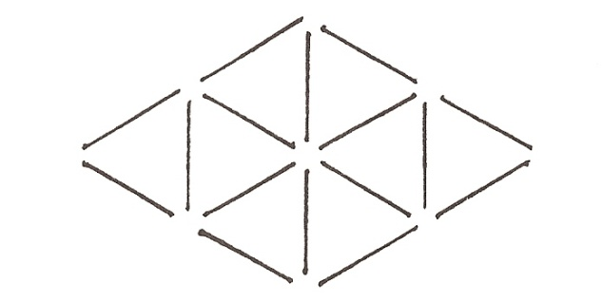

Answer:

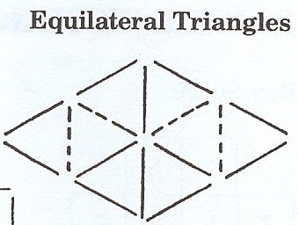

**Square within a Square**

Directions: Give each participant exactly 24 toothpicks. Ask them to arrange them in the pattern shown: three rows of three each; three columns of three each, resulting in nine adjacent small squares.

Ask them to remove eight toothpicks so that the result will be the formation of only two squares (which may be different sizes).

Tell them that if they have difficulty solving the task, they may nonverbally signal a request for corroboration of a potentially correct move. If they are proposing a correct move, respond with a loud and enthusiastic “yes!” Otherwise simply give a silent “no.”

When participants have completed the entire task successfully, they may help others by providing feedback and reinforcement.

|  |  |  |
| --- | --- | --- |
|  |  |  |
|  |  |  |
|  |  |  |

Answer: Remove the eight toothpicks that surround the smallest square in the center. This leaves a 4-toothpick square and the exterior 12-toothpick square, or a “square within a square.” See the key below:

|  |  |  |
| --- | --- | --- |
|  |  |  |
|  |  |  |
|  |  |  |

# Additional Games/Activities

## Mars Fraction Hunt

Objective: To provide students with practice in the use of fractions, changing fractions, using equivalent fractions, and paying attention to detail.

Materials:

* A Mars candy bar
* Classroom globe
* Fraction Hunt worksheet

How to Play:

Before the activity, the Mars bar should be hidden under the classroom globe. The Answer Key for the activity is:

For the first one to finish this there waits a prize if you use your head period clue mars is directly beneath the south pole period go look

Provide each student with an activity page. The students should write the appropriate parts of the word on the line to form a new word. When the message is complete, the first student to decode the message will be rewarded by finding the hidden treat (Mars bar).

**Fraction Hunt**

The first half of food + the last quarter of door. ____________________

The last third of hat + the first 2/5 of heavy. ____________________

The second 1/3 of office + the last 1/4 of door + the first 1/3 of street. _______________

The last half of go + the last 1/2 of done. ____________________

The last 1/8 of elephant + the first 1/5 of order. ____________________

The first 3/4 of fine + the last 3/4 of dish. ____________________

The last 1/6 of cement + the first 3/7 of history. ____________________

The last half of bath + the first 1/3 of end + the last 2/7 of require. __________________

The first 2/5 of water + the last 3/4 of fits. ____________________

The last 1/6 of Glenda. ____________________

The first 1/3 of principal + the first half of zero. ____________________

The first 1/7 of instant + the first third of fat. ____________________

The first 2/5 of young + the first 1/10 of understand. ____________________

The first 1/4 ugly + the first 1/5 of settlement. ____________________

The first 1/4 of youthful + the last half of pour. ____________________

The first 1/4 of hesitate + the last 2/3 of sad. ____________________

The first 1/3 of permanent + the first half of iodine. ____________________

The first 2/6 of clover + the last 2/4 of blue. ____________________

The first 1/4 of Mark + the last 3/5 of stars. ____________________

The last 1/4 of Meri + the first 1/5 of Susan. ____________________

The first 3/5 of dirty + the last 3/7 of perfect + the first 2/5 of Lynda. _________________

The first 3/4 of bent + the last 2/3 of breath. ____________________

The first 1/3 of Thomas + the first 1/8 of Endicott. ____________________

The first 3/5 of sound + the last 2/9 of Aylsworth. ____________________

The first quarter of positive + the first two thirds of Lee. ____________________

The first 4/9 of periscope + the last 2/5 of blood. ____________________

The first third of get + the second fourth of Jody. ____________________

The first half of loud + the last half of book. ____________________

### Algebra Equation Bingo

Try to be the first person to cross out all of the numbers in any row, column, or diagonal. In order to cross out a number, you must get that number as the solution to one of the equations shown below. Show that you have solved an equation by writing the equation number in the corner box next to the solution. The first group member to get a “bingo” must have his or her equation numbers verified by the other group members.

|  |  |  |  |
| --- | --- | --- | --- |
| **- 3** | **7** | **14** | **- 5** |
| **4** | **- 9** | **3** | **9** |
| **- 4** | **25** | **- 8** | **- 16** |
| **- 7** | **8** | **- 23** | **12** |

1. **-**32/8 = c
2. -84 ÷ (-6) = t
3. d = -16/2
4. -56 ÷ (-7) = s
5. b = 129 ÷ -43
6. -54 ÷ -18 = r
7. 238 ÷ -34 = k
8. y = -531 ÷ 59
9. -112 ÷ -16 = p
10. m = 828 ÷ 69
11. 272 ÷ =17 = n
12. -68 ÷ -17 = z
13. -75 ÷ -3 = a
14. e = 45 ÷ -9
15. -63 ÷ -7 = f
16. -138 ÷ 6 = h

### Algebra Terms Concentration

|  |  |
| --- | --- |
| Absolute Value | The distance an integer is from zero on a number line |
| Exponent | A number that indicates how many times another number is used as a factor |
| Integer | A number from the set {… -3, -2, -1, 0, 1, 2, 3 …} |
| Like Terms | Terms that differ only on their numerical coefficient |
| Unlike Terms | Terms that do not have the same variable factors |
| Monomial | A number, a variable or their product |
| Polynomial | A monomial or the sum or difference of two or more monomials |
| Equation | A statement that two quantities have the same value |

# 

### Vocabulary Match!

|  |  |  |
| --- | --- | --- |
| **Coefficient** | a constant that is being multiplied by a variable or by another expression | 7n in the expression 7(n+42) |
| **Constant** | to remain the same | n in the expression 37 + n |
| **Equation** | two equal values | 36 X 14 = 504 |
| **Exponent** | a number that tells how many times the base (of a power) is written in the product | The 2 in x2 |
| **Expression** | a mathematical/algebraic phrase | 36 X 14, 2x - y |
| **Inequality:** | compares two values that may or may not be equal | 36 X 14 > 500 |
| **Integers** | all positive and negative counting numbers including 0 | A number from the set {… -3, -2, -1, 0, 1, 2, 3 …} |
| **Terms** | parts of an expression or series separated by + or – signs, or parts of a sequence | 2a3 – 6 or 5*a*3, 2*xy*, and 3 |
| **Solution** | replaces the variable to produce a true equation | n + 19 = 21, n = 2 |
| **Variable** | a letter in place of a number, the value will be different in different equations | 2x + 4, 4y-2 |
| **Monomial** | an expression consisting of a single term | x, 2y |
| **Binomial** | an expression consisting of 2 terms connected by a plus or minus sign | 2x + 4, 4y-2 |
| **Trinomial** | an expression consisting of 3 terms | 2x + 4y - z |
| **Polynomial** | an expression of one or more algebraic terms of which consists of a constant multiplier by one or more variables raised to a power | 3x2 + 4x + 5 |

### Discovering Powers

For each pair of powers listed below determine which is greater. First guess, then check your answer using the calculator, **x2** or **yx** key.

|  |  |  |
| --- | --- | --- |
|  | Guess | Check |
| **1. 23 or 32** |  |  |
| **2. 45 or 54** |  |  |
| **3. 62 or 26** |  |  |
| **4. 89 or 98** |  |  |
| **5. 79 or 97** |  |  |
| **6. 58 or 85** |  |  |
| **7. 39 or 93** |  |  |
| **8. 34 or 43** |  |  |
| **9. 25 or 52** |  |  |
| **10. 17 or 71** |  |  |
| **11. 30 or 03** |  |  |
| **12. 2-5 or 5-2** |  |  |
| **13. 9-3 or 3 -9** |  |  |
| **14. 01 or 10** |  |  |

**Write five statements about your findings**

|  |
| --- |
| **1.** |
| **2.** |
| **3.** |
| **4.** |
| **5.** |

## A Few Patterns

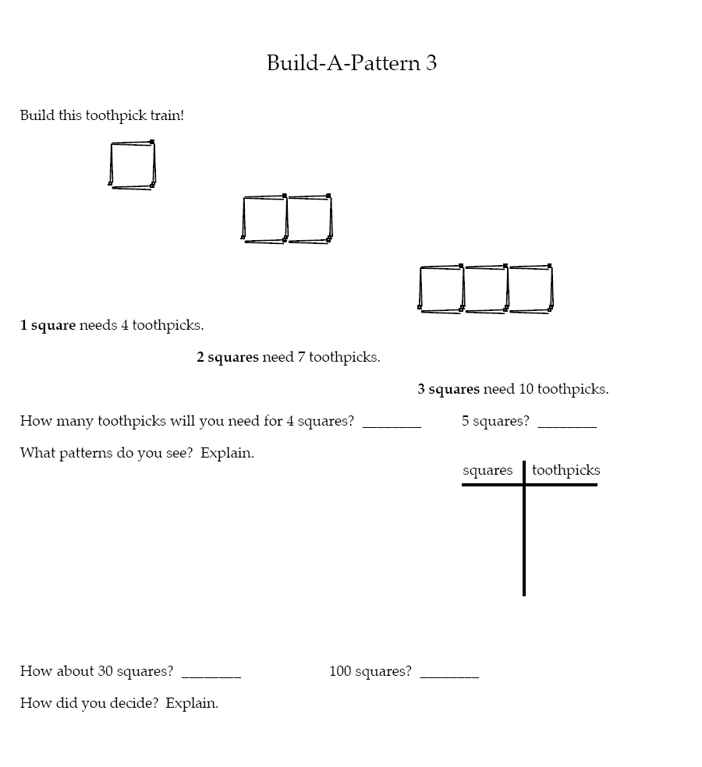

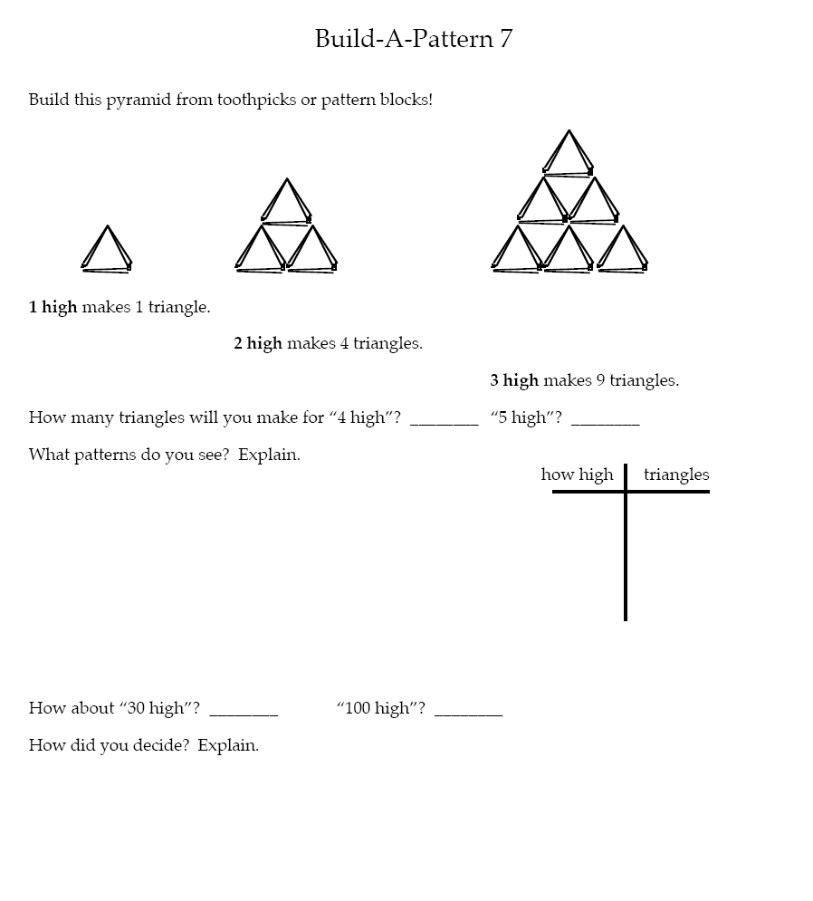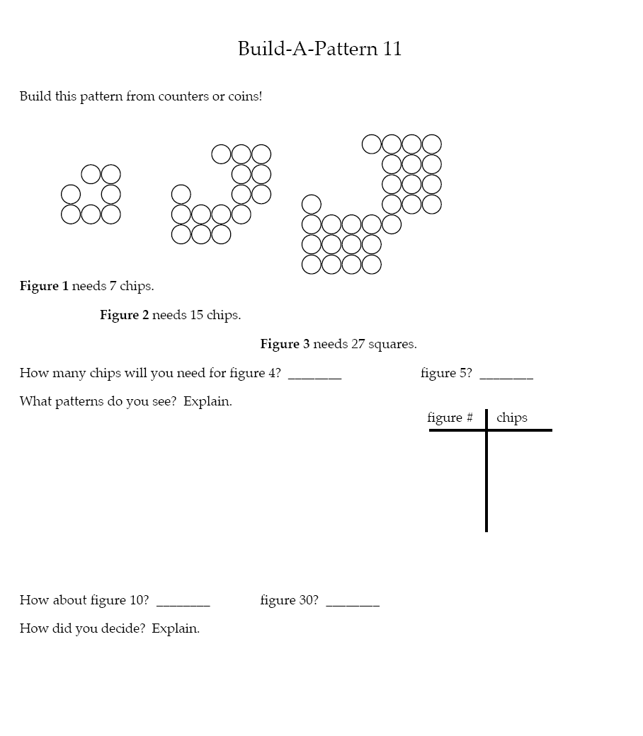

## Starting with Number Lines for Positive and Negative Integers

**Learning Objectives:**

The students will be able to

* Demonstrate an understanding that a horizontal number line moves from left to right using lesser to greater values
* Read and understand positive and negative integers
* Recognize positive and negative numbers in practical contexts.

**Materials/Resources:**

* Papers with large individual numbers from -9 to 9
* Tennis ball
* Number line word problems handouts

**Activities:**

* Ask students how 2 is different from -2.
* Ask students when they have seen negative numbers.
* Give each student a piece of paper with a big number on it. (Some students can get 2 papers.) Ask students to put the numbers in order on the floor. You can put down 1 and 2, to get them to start in the right direction.
* Ask all students to stand by a number on the line. Give one student (on positive 3) the tennis ball. Say “if we start at 3 and pass the ball down the line 5 times, where will it end up?” Have students pass the ball to the person next to them and count each pass. Repeat for a few problems. You can phrase the problems like word problems. (The temperature at noon is 4 degrees. The temperature falls 7 degrees. What is the new temperature?) Explain that these are “where do you end up?” problems.
* Give one student (on -2) the tennis ball. Say “how far is -2 from positive 5?” Have students pass the ball and count how many passes are between -2 and 5. Repeat for a few problems. You can phrase the problems like word problems. (The temperature was -4 degrees. Now it is -6 degrees. How much did the temperature drop?) Explain that these are “how many in-between” problems.
* Have students go back to their seats where they can still see the number line. Give students the number line word problems handout. Solve the first few together. For each problem, either demonstrate yourself or ask a student to   
  “walk” the problem. (Stand on the first number they give you, and then count steps to get to the next number.)
* Students work together or independently to solve and write their own word problem using positive and negative integers on the number line.

**Assessment:**

Students turn in their own number line word problems

**Wrap-up/Reflection:**

Discussion of what is easy and what is difficult about the problems.

**Follow up:**

* Type up the student’s problems to solve the next day.
* You can do the full activity again another day with the students making a vertical number line.
* Use the number line to answer the following questions:

1. The temperature in the morning is -4 degrees. At noon the temperature is 6 degrees. By how many degrees has the temperature risen?
2. Anna is standing on a rock that is 5 feet above sea level. She jumps off the rock. She hits the water and then goes 3 feet below the surface of the water. How many feet did she fall?
3. Gina gets into an elevator on the 5th floor going down. She passes the ground level, and travels to the 3rd floor below the ground. (Floor -3) How many floors did Gina travel in the elevator?
4. Ronald starts off on the 3rd floor of a building. He travels 7 feet down. What floor does he end up on?
5. The temperature is 6 degrees. It drops 7 degrees during the night. What is the temperature during the night?
6. Carlos gets on an elevator at the 2nd floor below the ground. (Floor -2) He travels up in the elevator 7 floors. What floor does he end up on?
7. The temperature is -5 degrees and rises 10 degrees. What is the new temperature?
8. You start with $3, but the experience a loss of $9. How can you represent this with a positive or negative number?

Write 2 problems of your own:

9._________________________________________________________________________________________________________________________________________________________________________________________________________________________________________

10.________________________________________________________________________________________________________________________________________________________________________________________________________________________________________